- theLLMStore:
Overview
This folder contains the core components of a modern website mockup. The website is designed for theLLMStore, a service that specializes in “AI Search Visibility & Optimization.”

1. index.html (The Main Website)
- What it is: This is the heart of the project. It is the actual “blueprint” for the website.
- What it does:
  - Layout: It structures the entire page, including the navigation menu (Home, Features, FAQ, etc.), the main marketing sections, and the footer at the bottom.
  - Visuals: It uses “Tailwind CSS” to make the site look modern, dark, and professional.
  - Interactive Charts: It contains computer code that draws three interactive charts to show data like “Visibility Scores” and “Sentiment Analysis” for brands.
  - Sections: It includes testimonials from famous brands, a pricing table comparing different service plans, and a “Frequently Asked Questions” area.
2. favicon.jpg (The Browser Icon)
- What it is: A small image file.
- What it does: This is the tiny icon you see on the browser tab when you visit a website. It represents the brand and helps users identify the tab quickly among others.

Render Setup:
- When setting this in render from scratch choose the Static Site option.
- Type echo “No build required” in the build command.
- 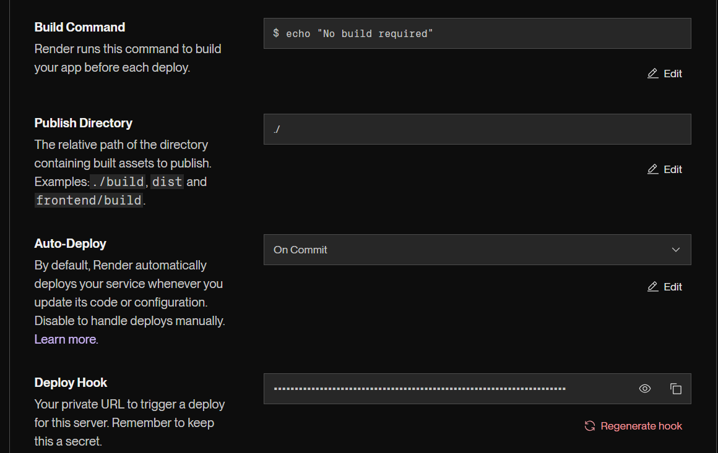

- WebAnalyzer:
What This Project Does
This is a web application that helps you understand how visible your website is to AI systems (like ChatGPT, Google's AI, and other smart assistants). You enter a website link, and it gives you a score showing how well AI can find and understand your site.

Files and What They Do
.env
- This file stores API needed to run the app.
- For this application I have used GROQ_API_KEY which is free of cost.

main.py
What it does: This is the “brain” of the application. It:
- Visits the website you enter and takes a picture of it.
- Checks 13 different things about the website (like how easy it is to read, whether images have descriptions, and how well the site is organized).
- Calculates an overall “AI Visibility Score” from 0 to 100.
- Uses an AI assistant to give you tips on how to improve your score.
- Uses an AI assistant to check if the website is mentioned in AI responses.

frontend/index.html
What it does: This is the main page you see when you open the app. It includes:
- A text box where you type the website address.
- An “Analyze” button to start the check.
- A circular meter that shows your score.
- A section displaying all the detailed scores.
- A chat button to ask questions about your results.

frontend/script.js
What it does: This file makes the webpage interactive. It:
- Sends your website link to the analyzer when you click “Analyze”.
- Updates the score display with your results.
- Shows improvement suggestions.
- Handles the chat feature so you can ask questions about your scores.

frontend/styles.css
What it does: This file controls how the app looks, including:
- The dark blue and black background colors.
- The glowing green score meter.
- The chat window design.
- Button animations while the analysis runs.
- The floating chat icon in the corner.

Render Setup:
- When setting this in render from scratch choose the Web Service option.
- Connect the GitHub repository.
- All the code to run the application is setup in docker file, in render we can setup the docker path as ./Dockerfile to run the application.
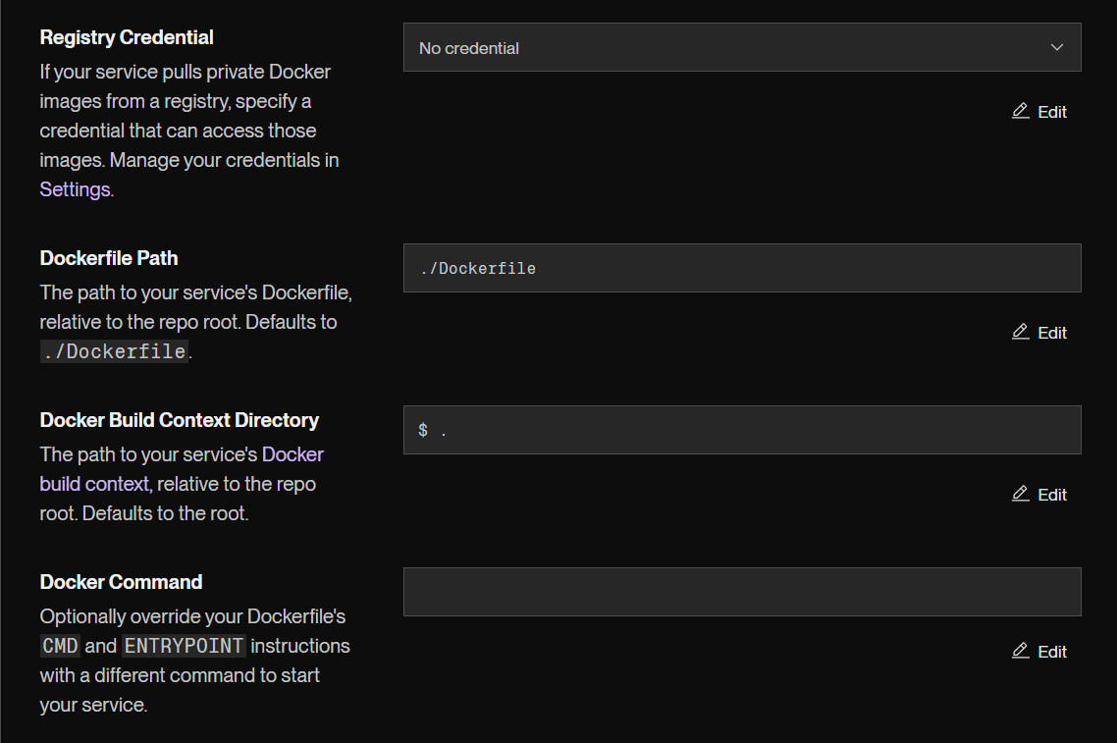
- Also add GROQ_API_KEY, PORT, PYTHON_VERSION in the environment. To edit the API, click edit and paste your new GROQ_API_KEY.
